QUADRATIC EQUATION
import java.util.*;
public class quadraticeq {
public static void main(String[] args) {
Scanner sc=new Scanner(System.in);
double a=sc.nextInt();
double b=sc.nextInt();
double c=sc.nextInt();
double dis=Math.pow(b,2)-(4*a*c);
double r1,r2;

if(dis>0){
r1=(-b+Math.sqrt(dis))/2*a;
r2=(-b-Math.sqrt(dis))/2*a;
System.out.println(r1+" "+r2);
}
if(dis==0){
r1=-b/2*a;
r2=r1;
System.out.println(r1+" "+r2);
}
if(dis<0){
System.out.println("imaginary roots");
}

}
}

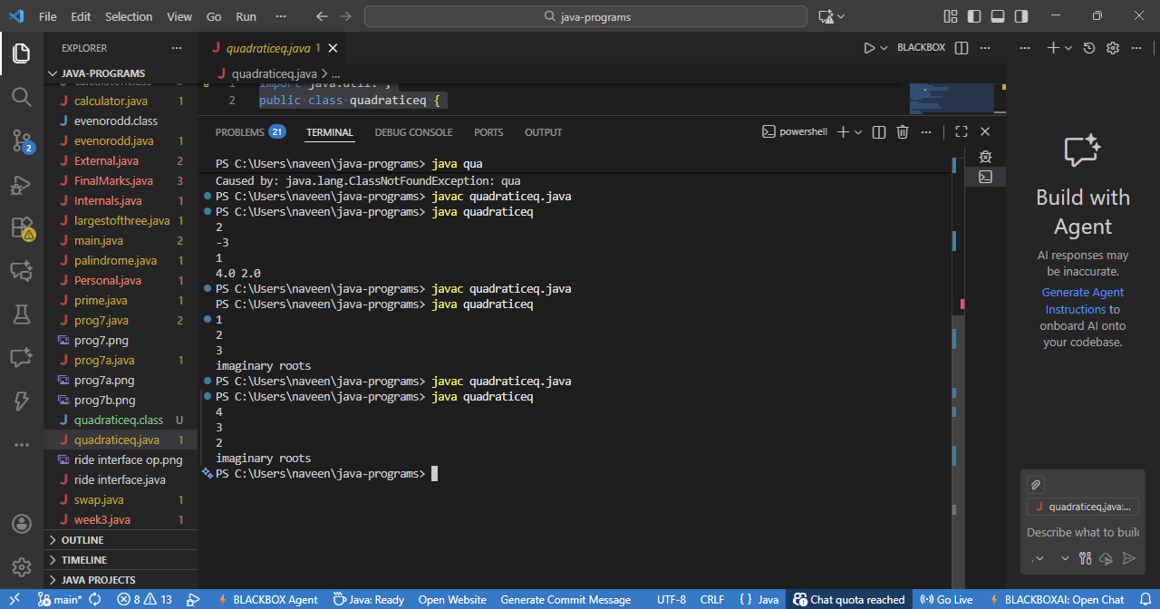

1.Calculator
import java.util.*;
public class calculator {
public static void main(String[] args) {
Scanner s=new Scanner(System.in);
System.out.println("enter two values of a numbers ");
int a=s.nextInt();
int b=s.nextInt();
System.out.println("enter the option 1-add 2-sub 3-mul 4-div");
int opt=s.nextInt();
switch(opt){
case 1:
System.out.println(a+b);
break;
case 2:
System.out.println(a-b);
break;case 3:
System.out.println(a*b);
break;case 4:
System.out.println(a/b);
break;
default:
System.out.println("invalid input");
}
}
}
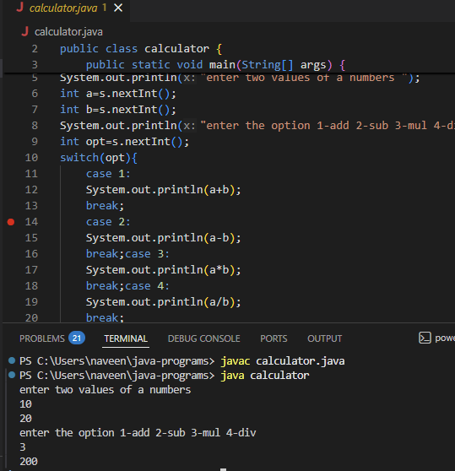

2.EVEN OR ODD
import java.util.*;
public class evenorodd {
public static void main(String[] args) {
Scanner s=new Scanner(System.in);
int n=s.nextInt();
if(n%2==0)System.out.println("even");
else System.out.println("odd");
}
}
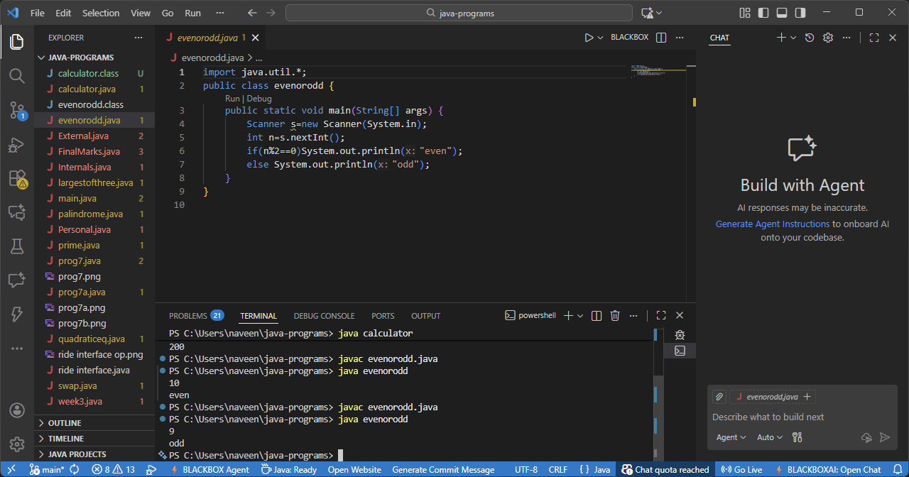

3.PALINDROME
import java.util.*;
public class palindrome {
public static void main(String[] args) {
Scanner sc=new Scanner(System.in);
String s=sc.nextLine();
s=s.toLowerCase();
int l=0;
int r=s.length()-1;
boolean found=true;
while(l<=r){
if(s.charAt(l)!=s.charAt(r)) found=false;
l++;
r--;
}
if(found){
System.out.println("palindrome");
}else
System.out.println("not an palindrome");

}
}
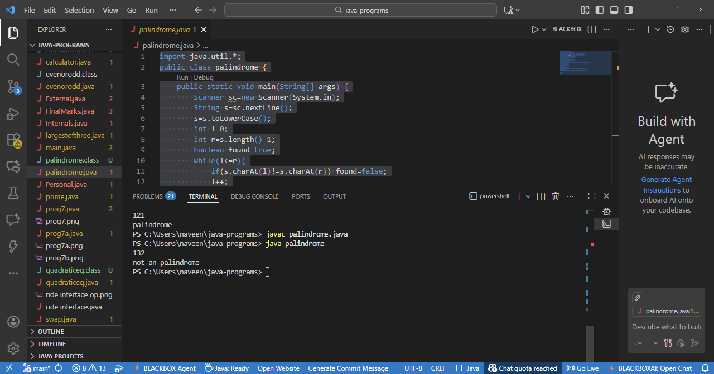

4.PRIME NUMBER
import java.util.*;
public class prime {
public static boolean isprime(int n){
if(n<=1) return false;
for(int i=2;i*i<=n;i++){
if(n%i==0) return false;

}return true;
}
public static void main(String[] args) {
Scanner s=new Scanner(System.in);

int a=s.nextInt();
boolean found=false;
for(int i=2;i<=a/2;i++){
if(isprime(i) && isprime(a-i)){
System.out.println(a+"can be expressed a sum of two prime"+i+" "+(a-i));
found=true;
}

}
if(!found){
System.out.println("cant be expressed");
}

}
}
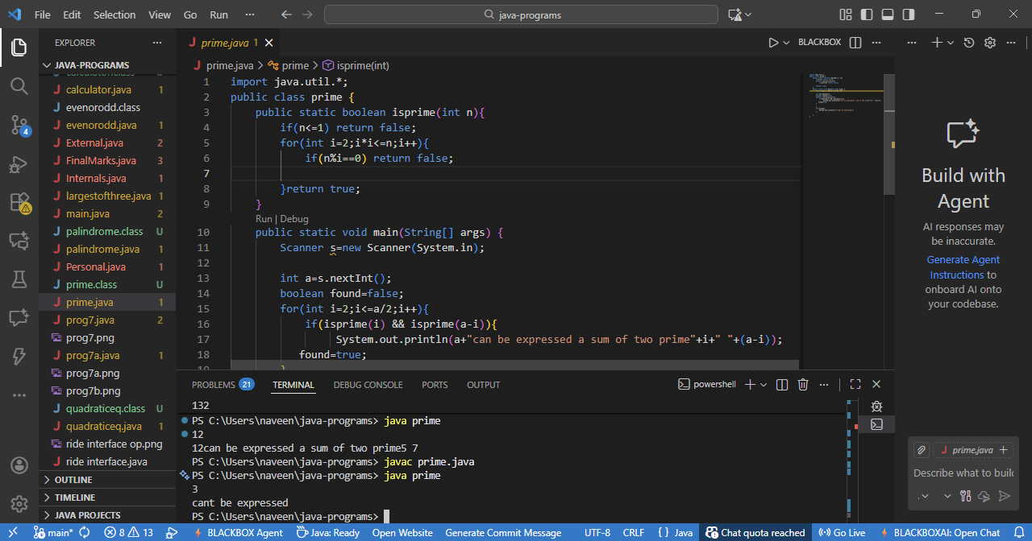
5.SWAP

import java.util.Scanner;

public class swap {

public static void main(String[] args) {
Scanner s=new Scanner(System.in);
int a=s.nextInt();
int b=s.nextInt();
int t=a;
a=b;
b=t;
System.out.println("after swaping value is"+" "+a+" "+b);

}
}
